|  |  |
| --- | --- |
|  | **Qatar University**  **College of Engineering**  **Department of Computer Science and Engineering** |

**Mobile Application**

**Project Phase 1: YalaPay**

**Project Group Members:**

**Hanan Rashid – 202006354**

**Rain Alkai –**

**Arwa Alobeid-202102413**

* **UI Screenshots:**
* 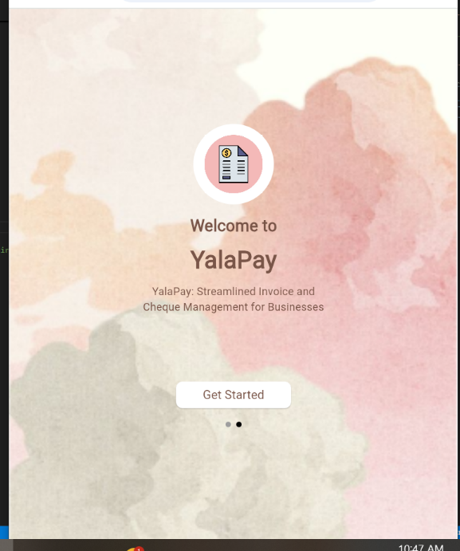Startscreen:
* Login:
* **Dashboard (Responsive):**

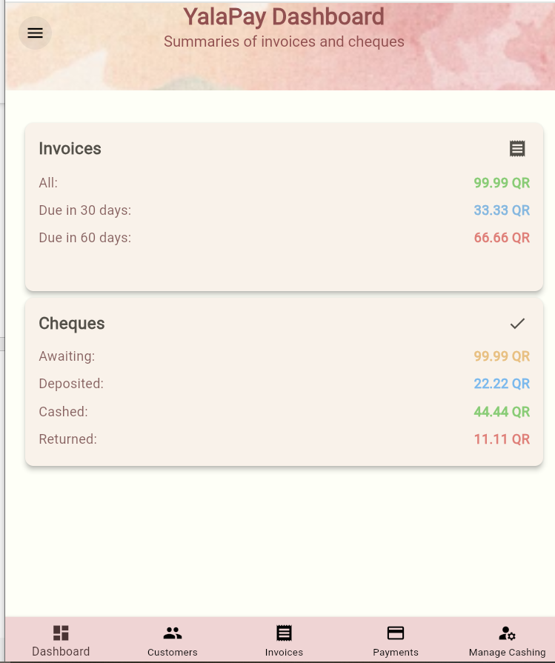 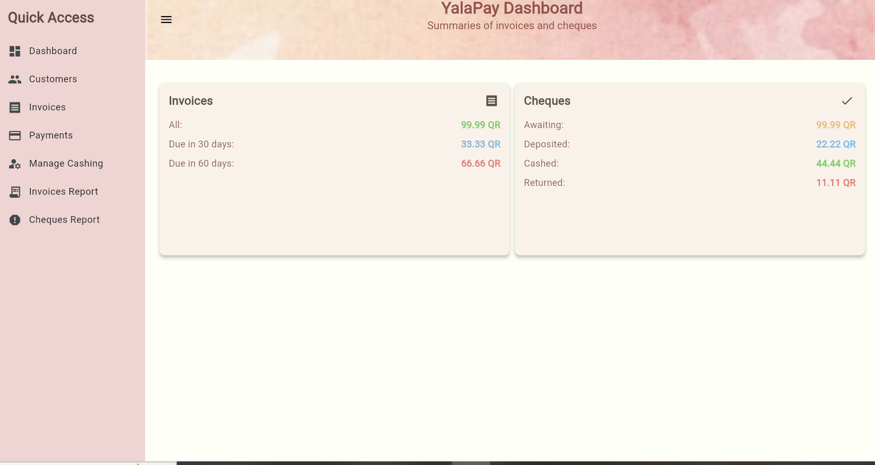

* 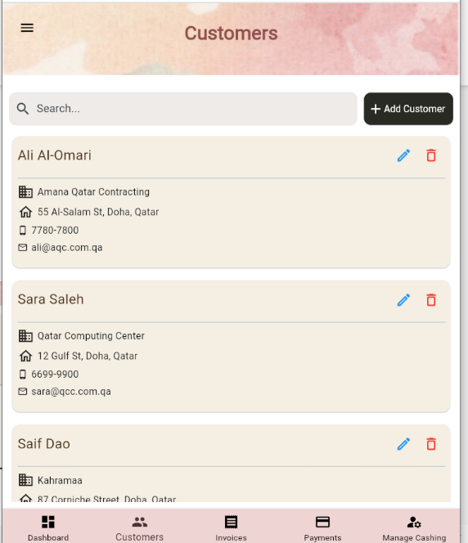Customers (Responsive) :

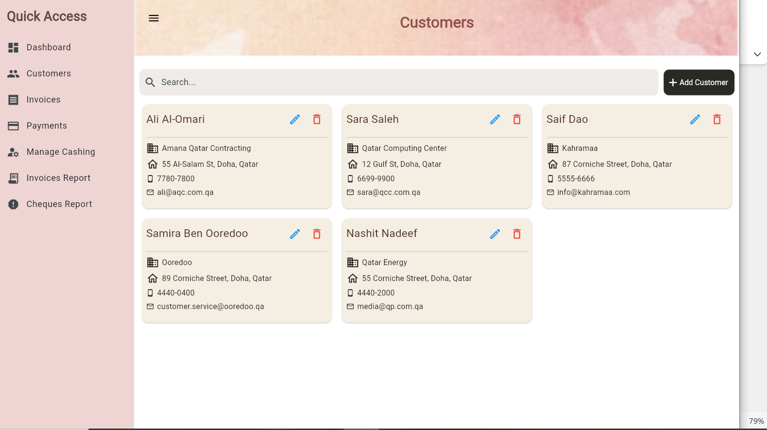

* **Customer Delete:**

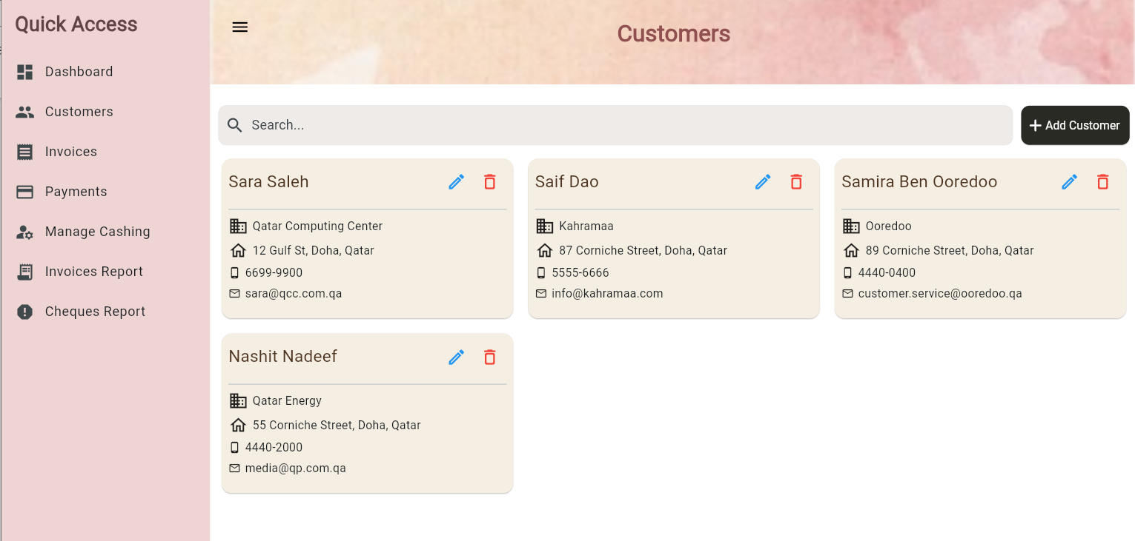

* **Customer Search:**

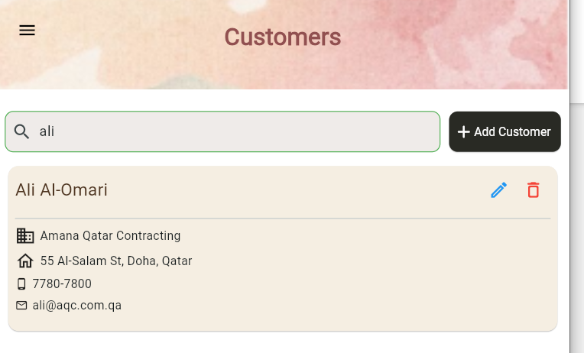

* **Customer Add:**

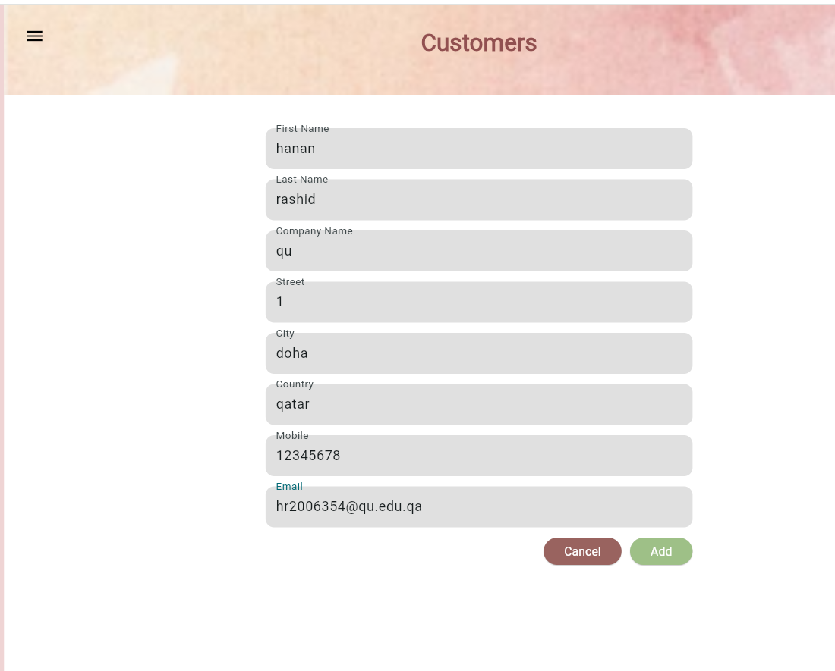

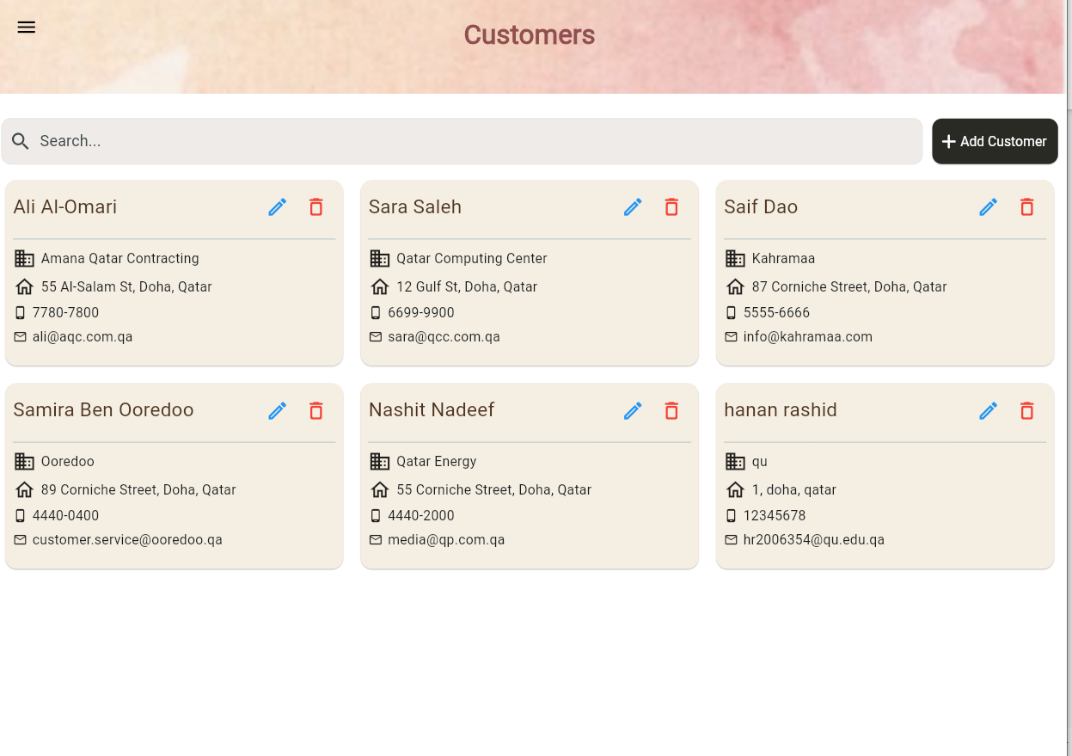

* **Customer Update:**

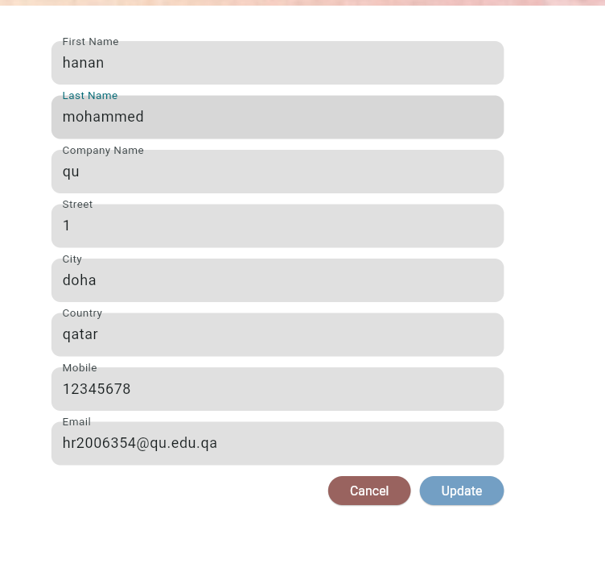

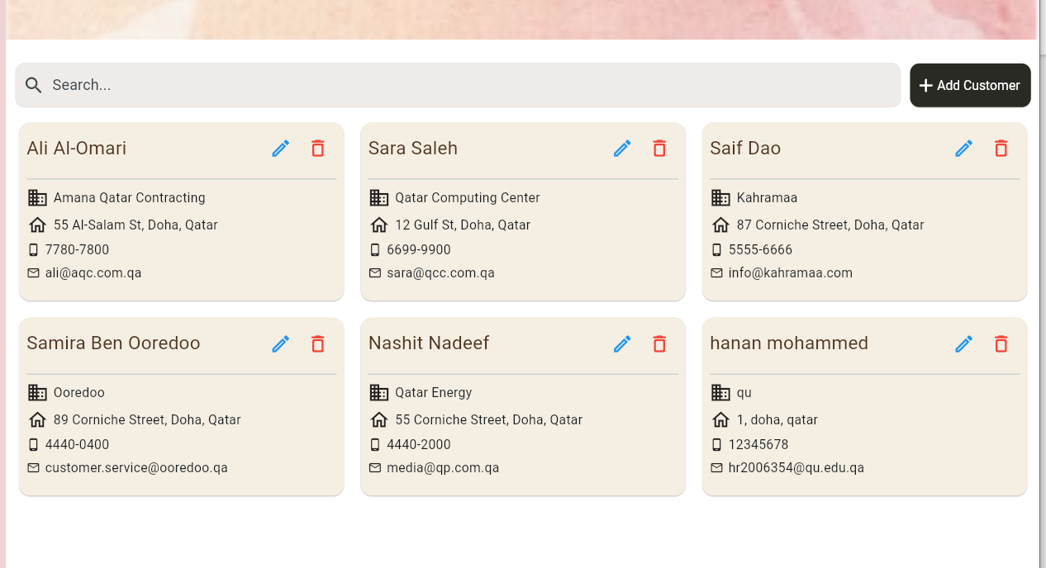

* **Invoices ( Responsive) :**

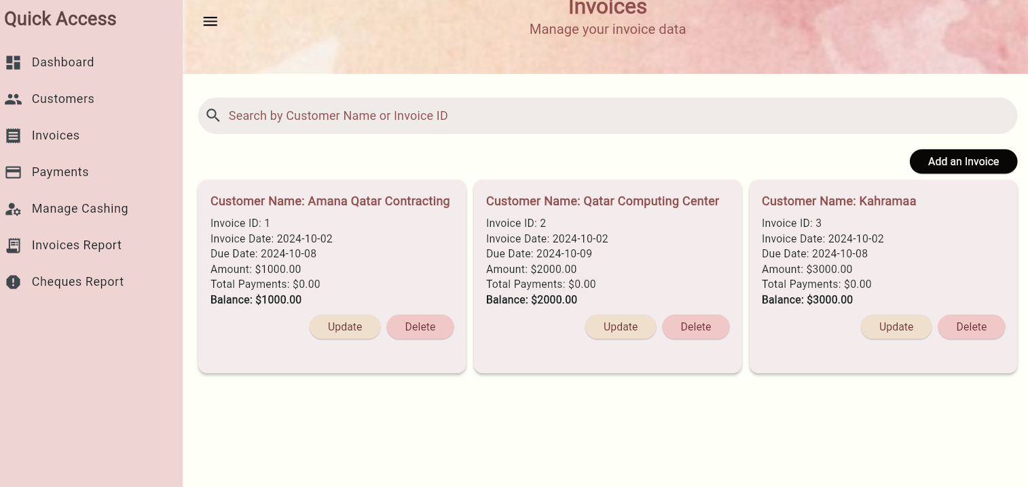

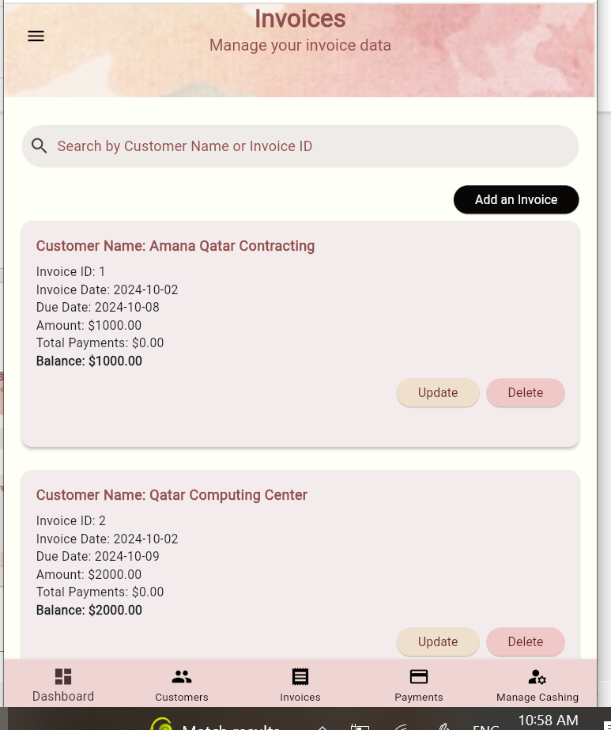

* **Delete invoice:**

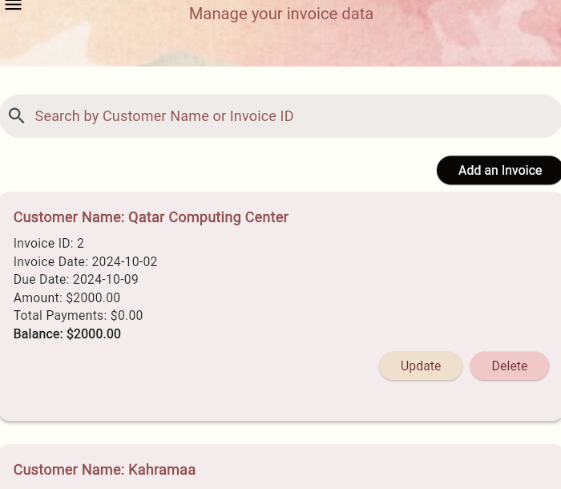

* **Add invoice:**

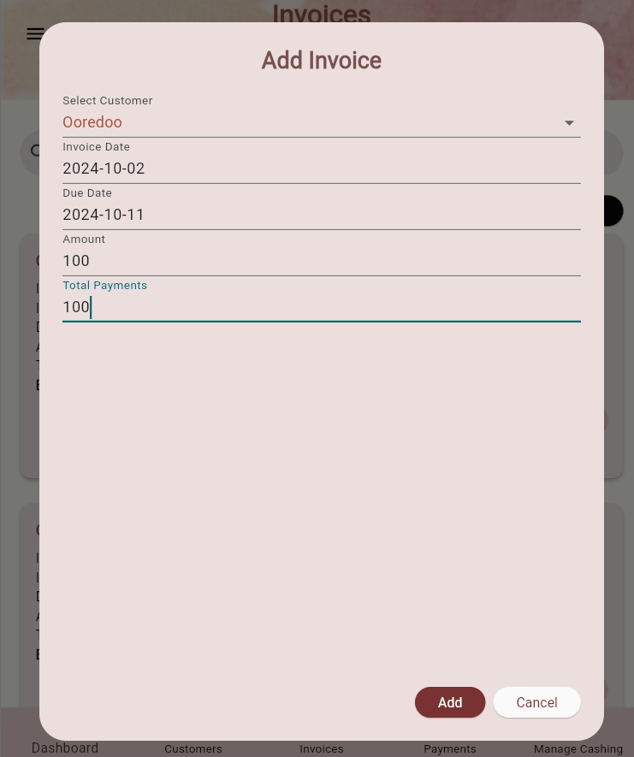

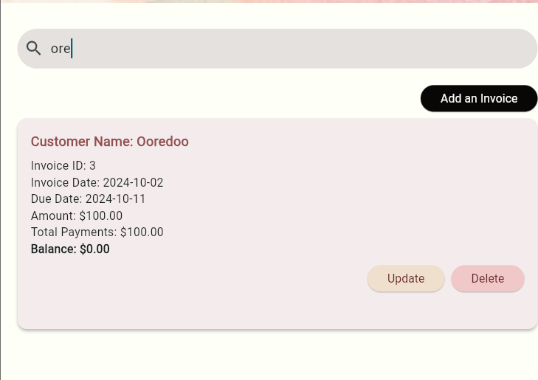

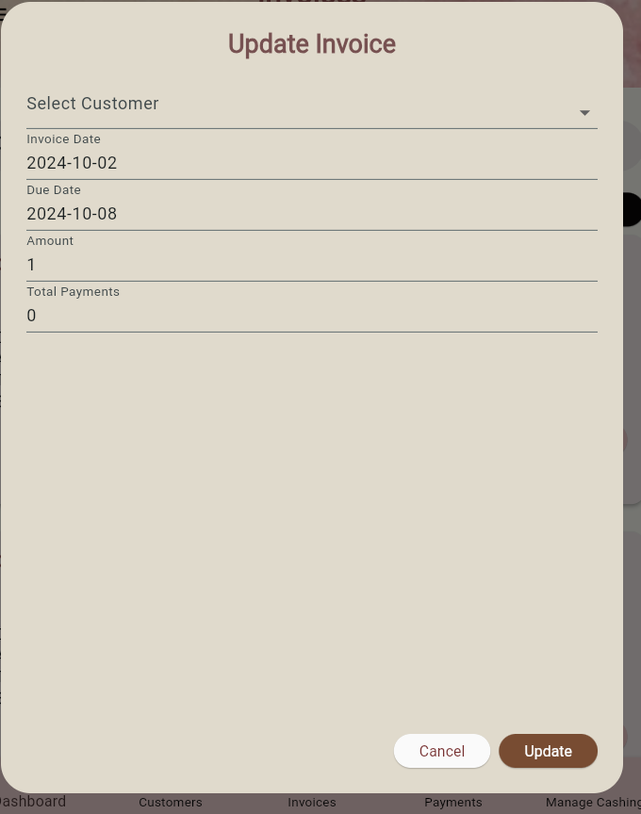

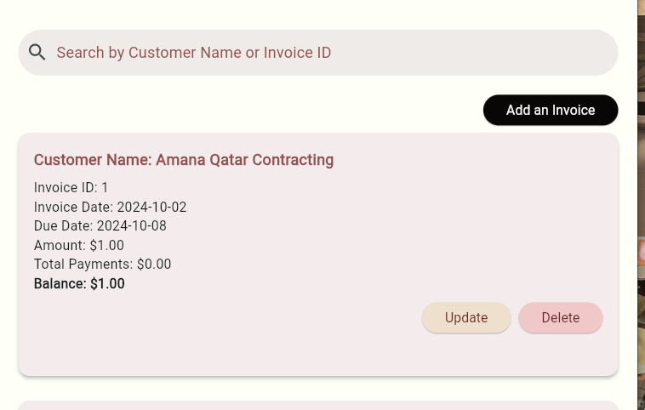

**-U6 - Manage Cashing Cheques**

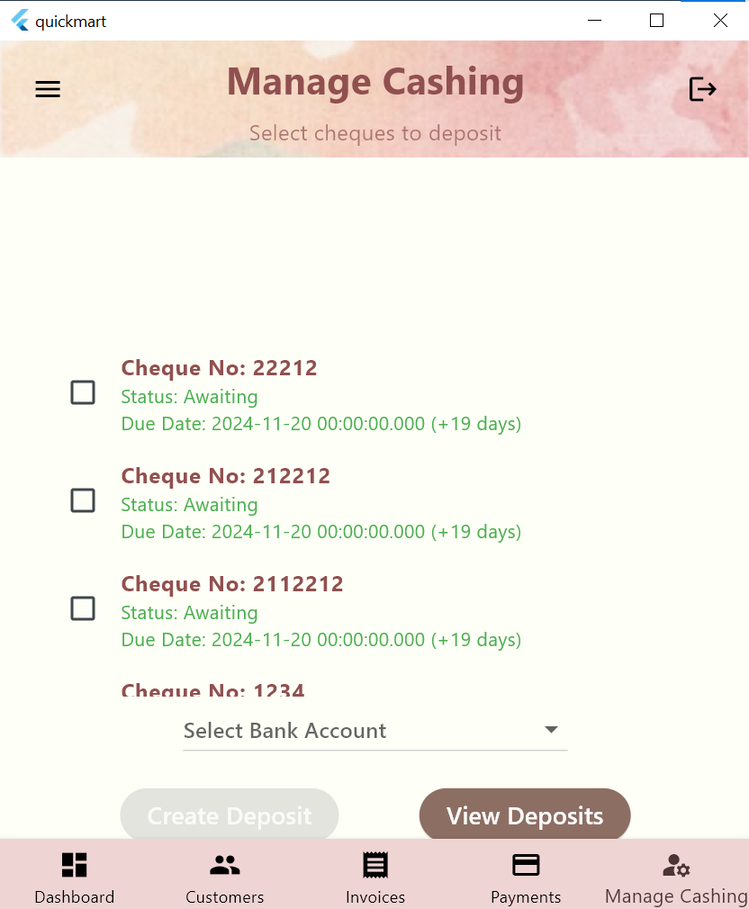

**The cheques no and status and due data are presented and cheques past their due date have their information written in red and the number of days past due are shown**

**You must check or or multiple cheques and choose a bank account to deposite to before making a deposite**

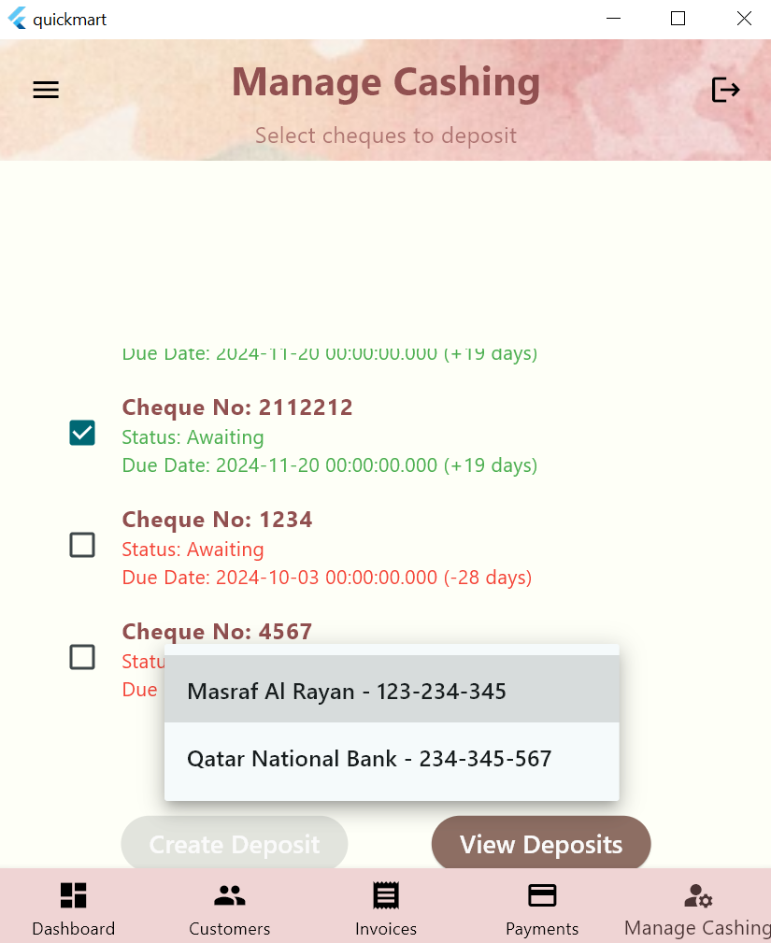

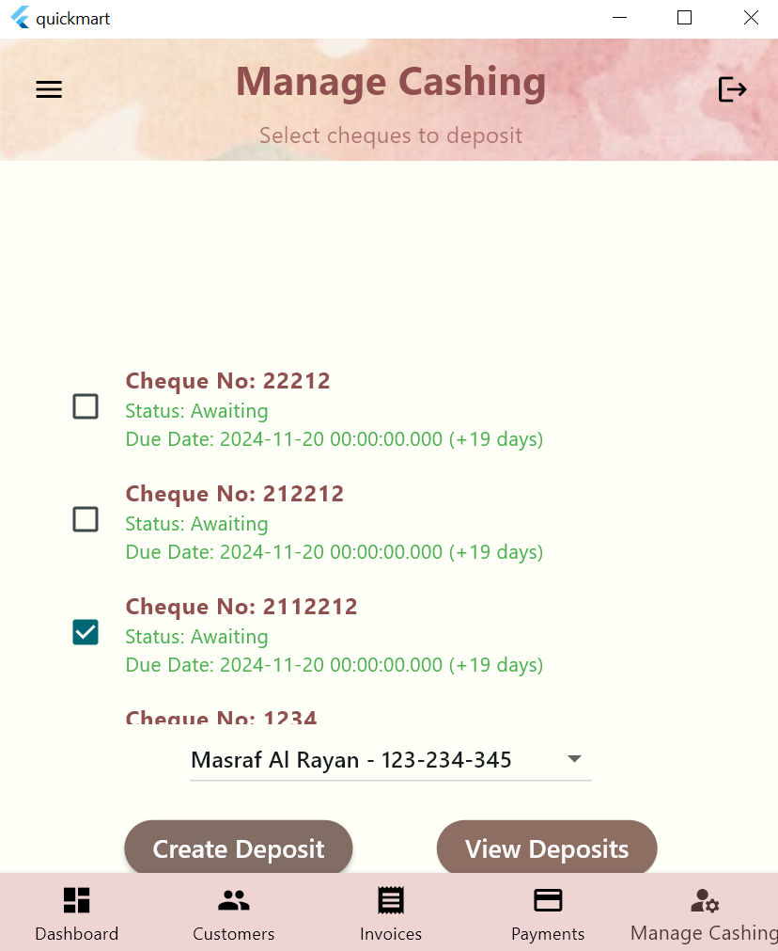

**Deposited cheque is greyed out and u can deposite multiple cheques at the same**

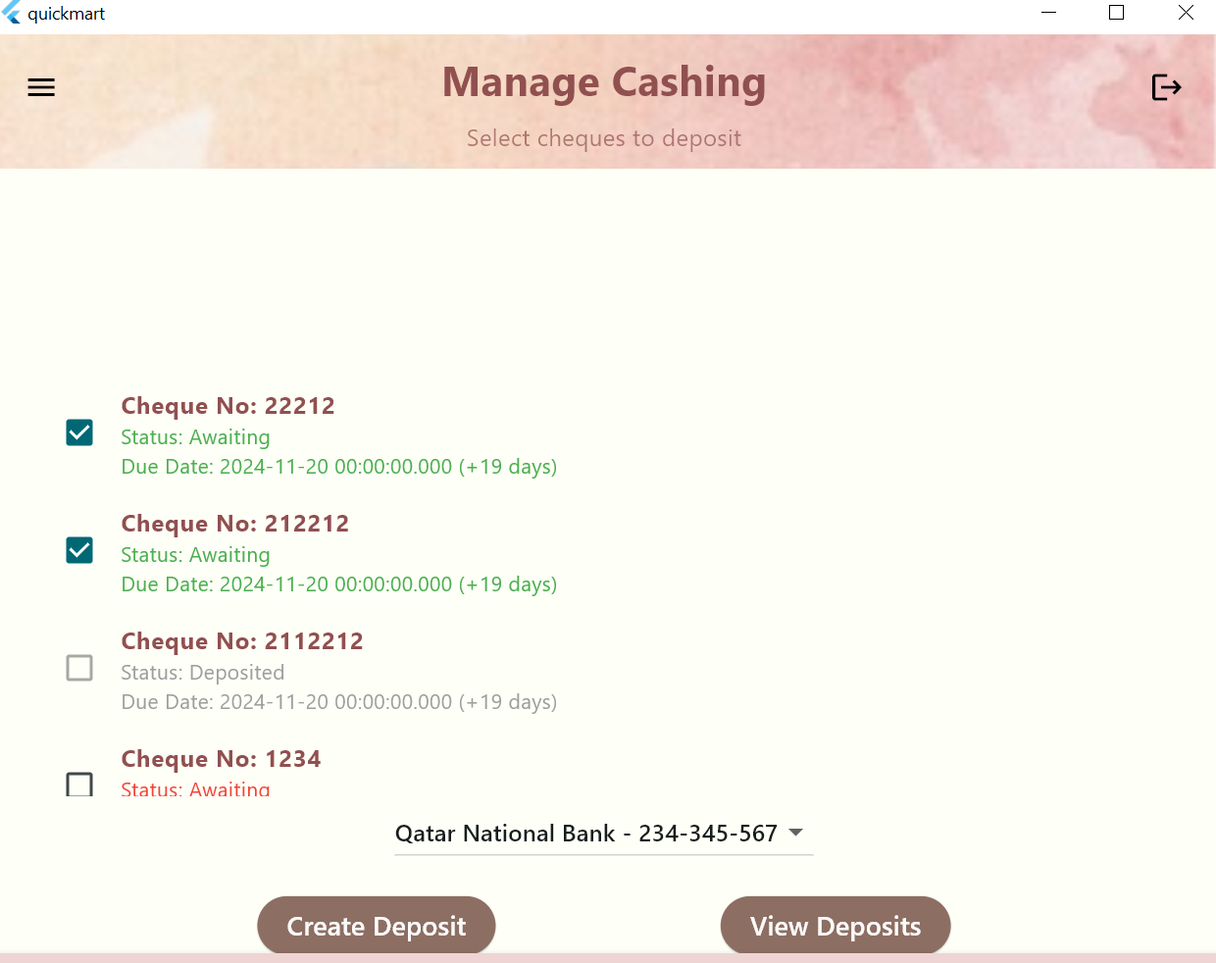

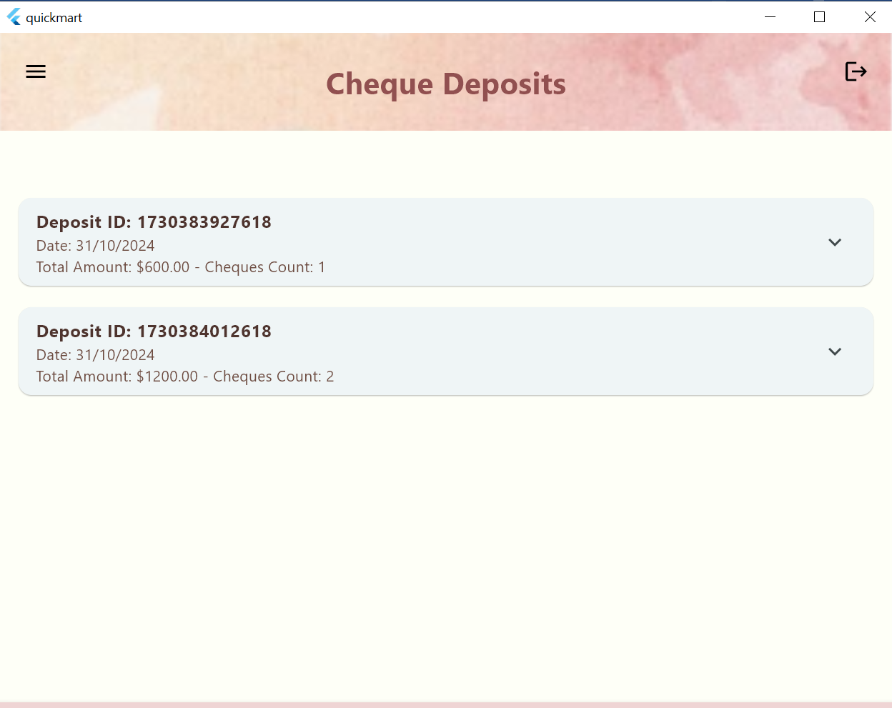

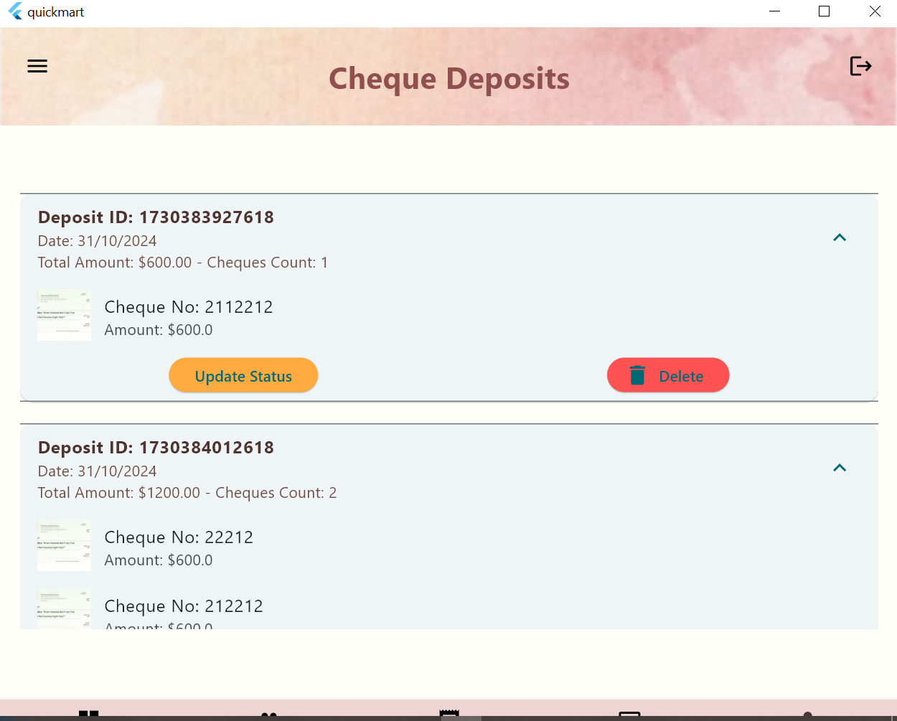

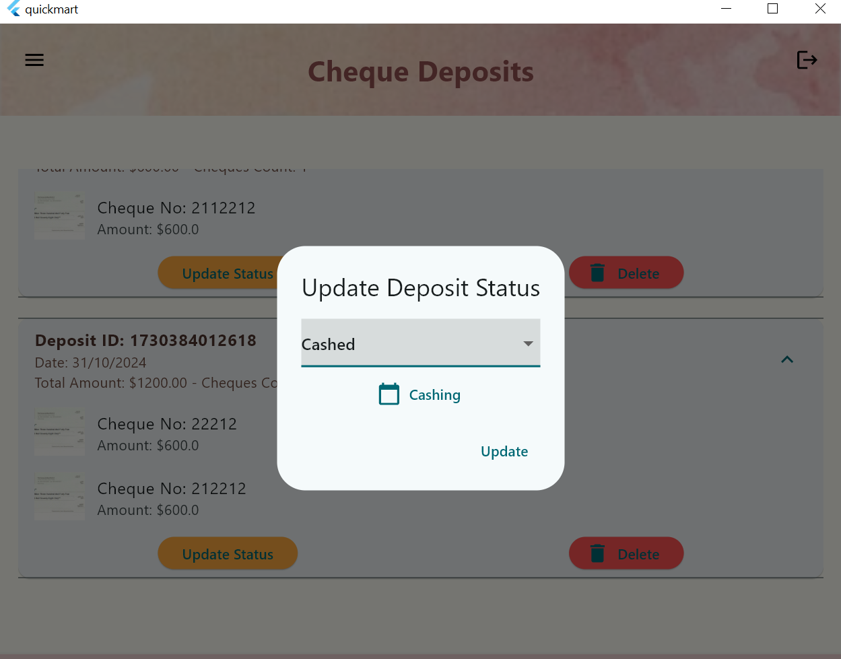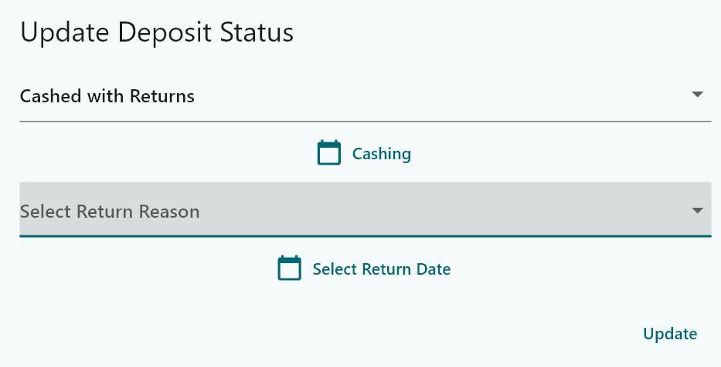

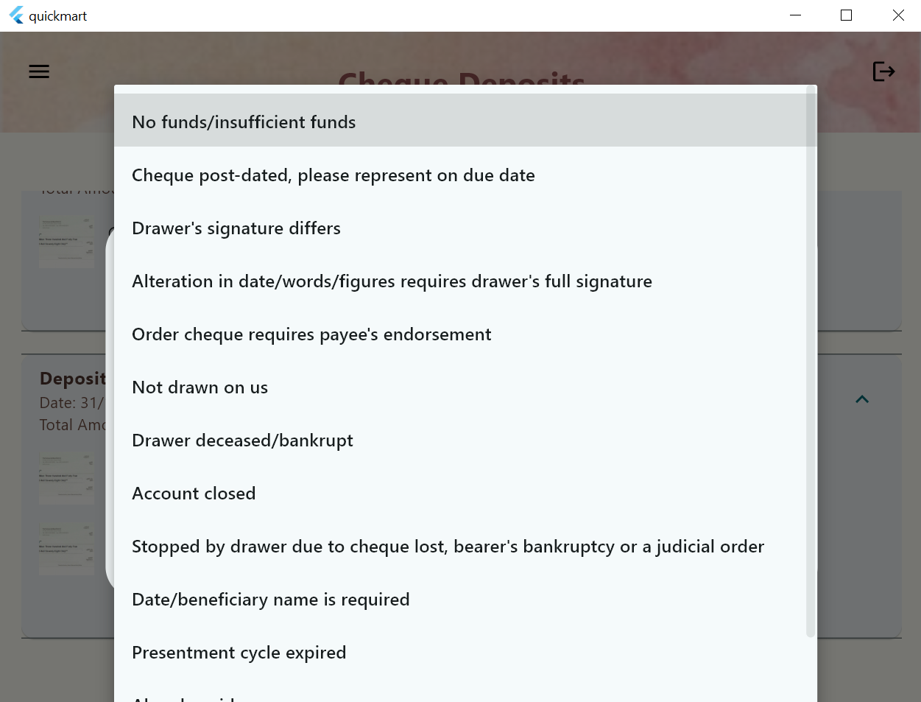

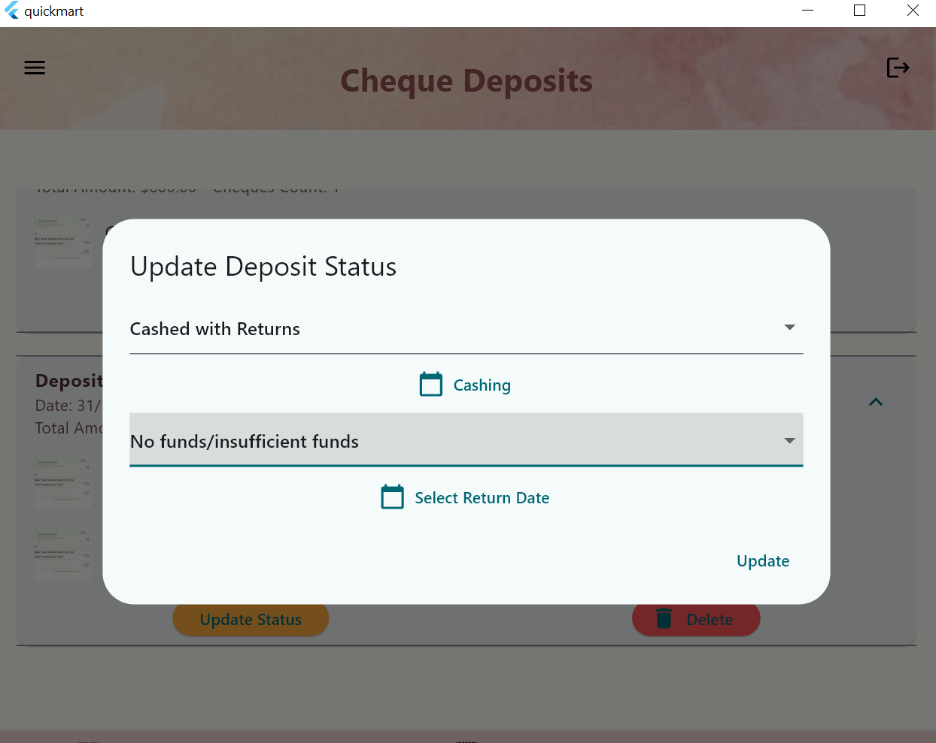

**Cheque report  
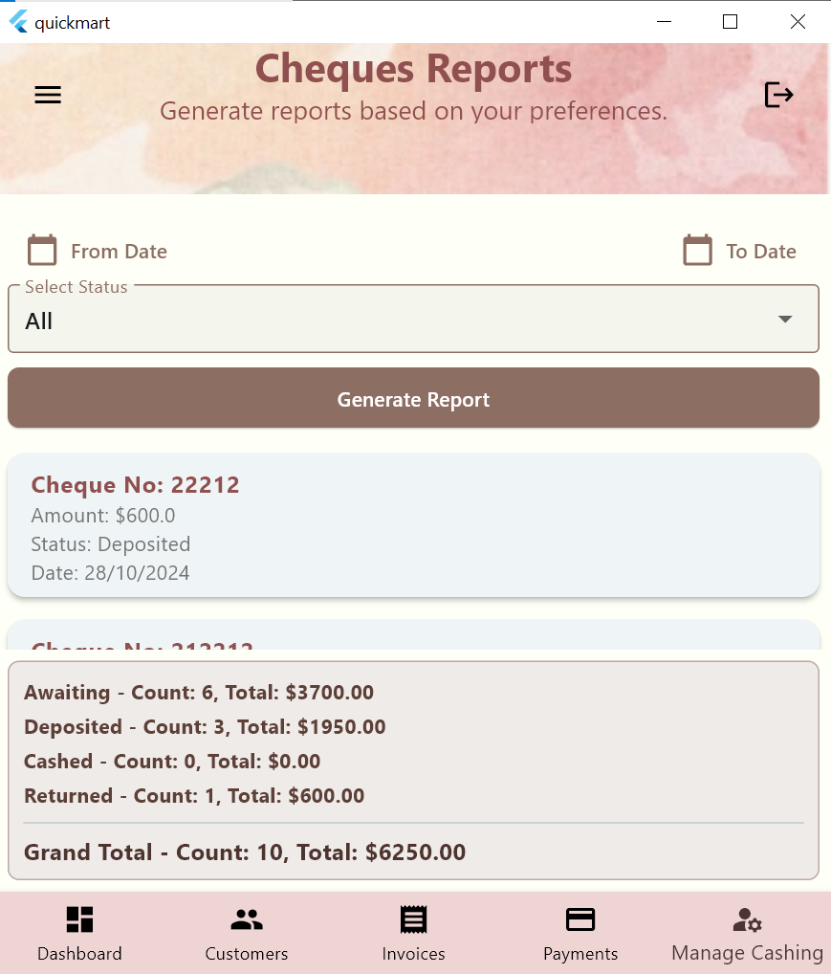**

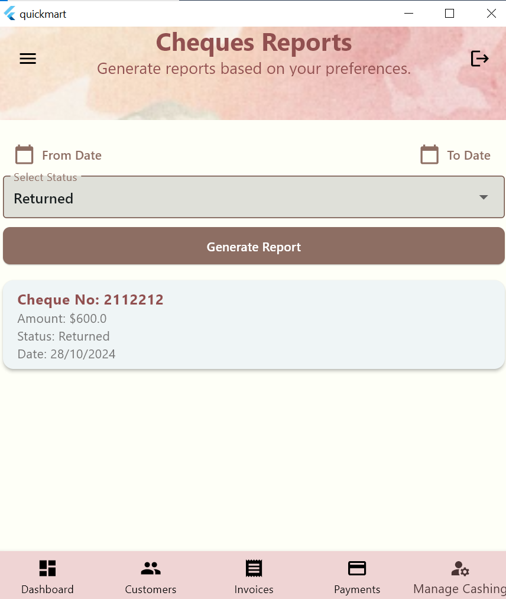

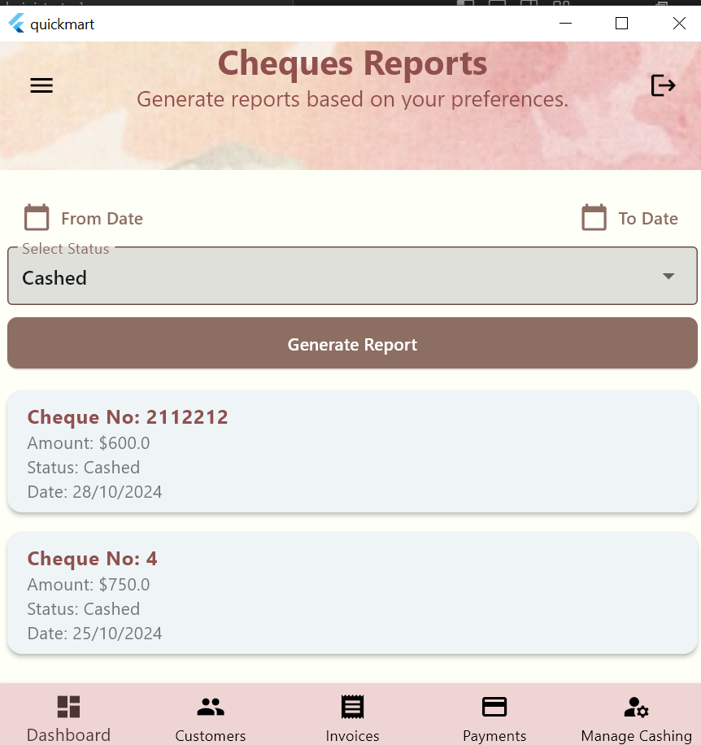

**Filtering using the from date   
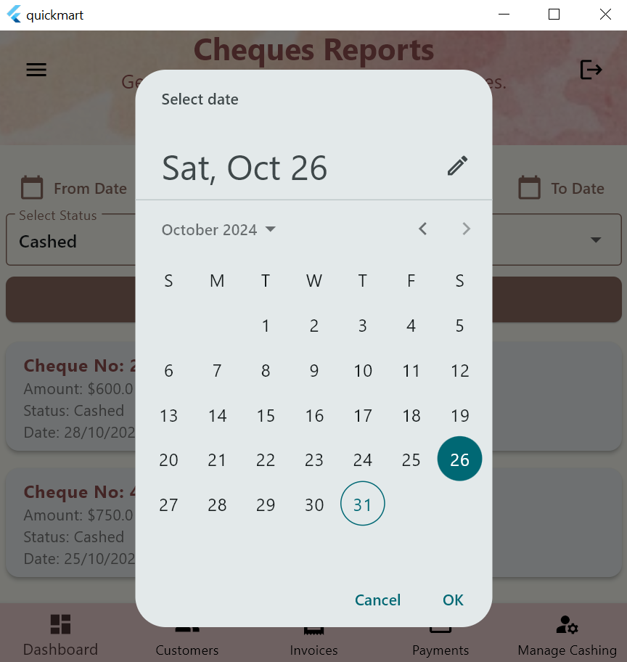**

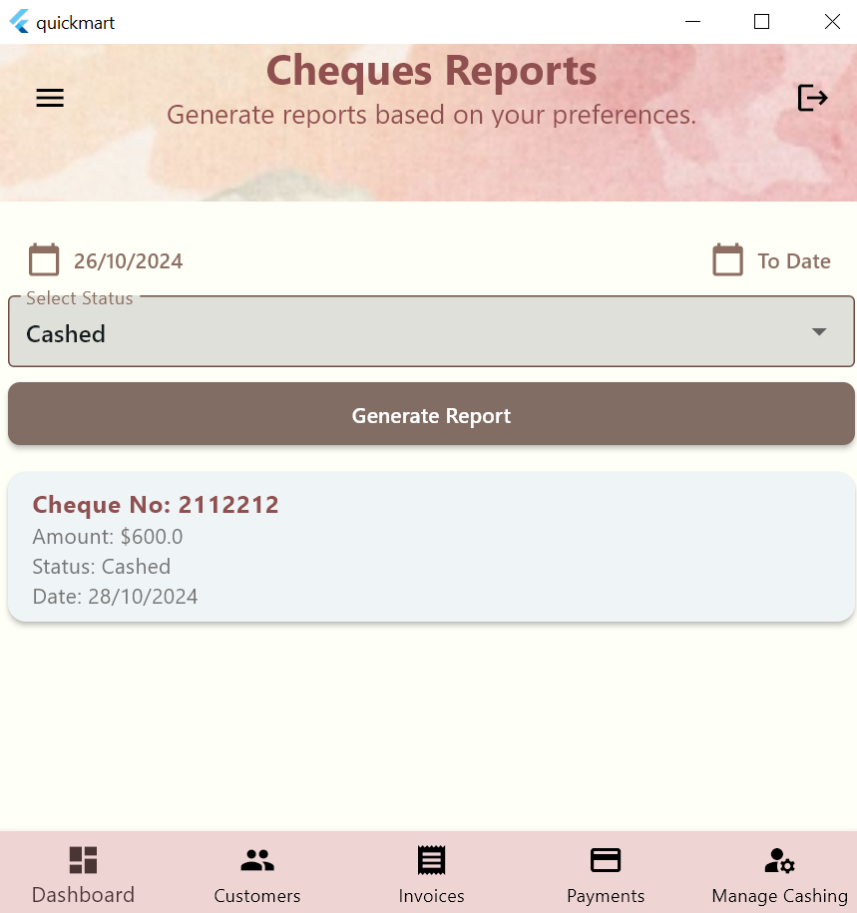

**The delete button deletes the cheque**

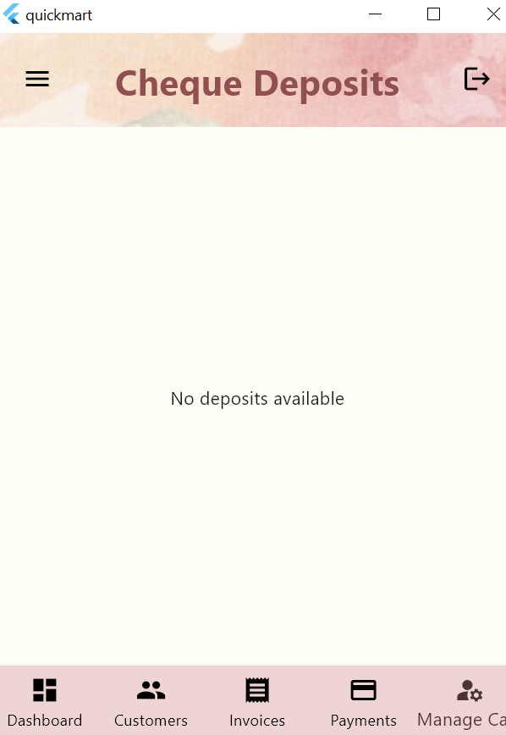

**Invoices   
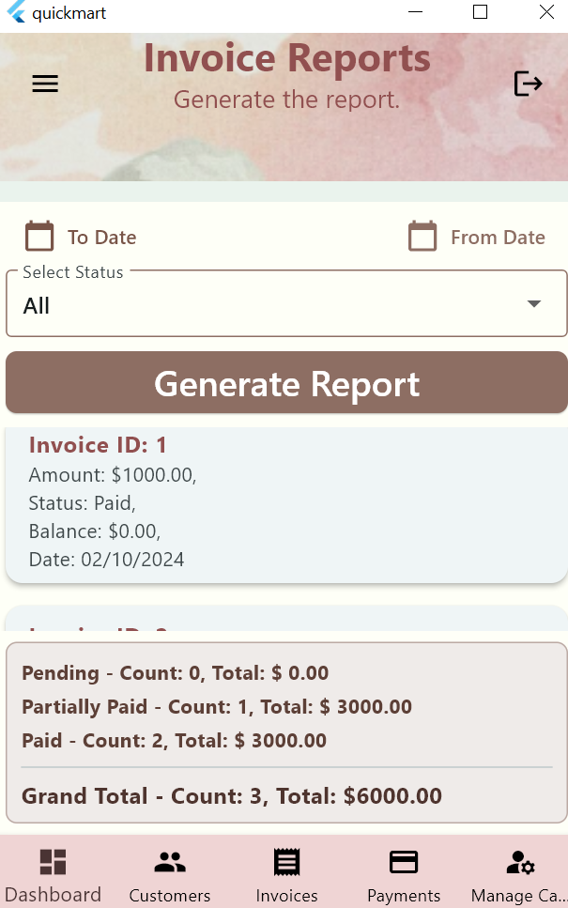**

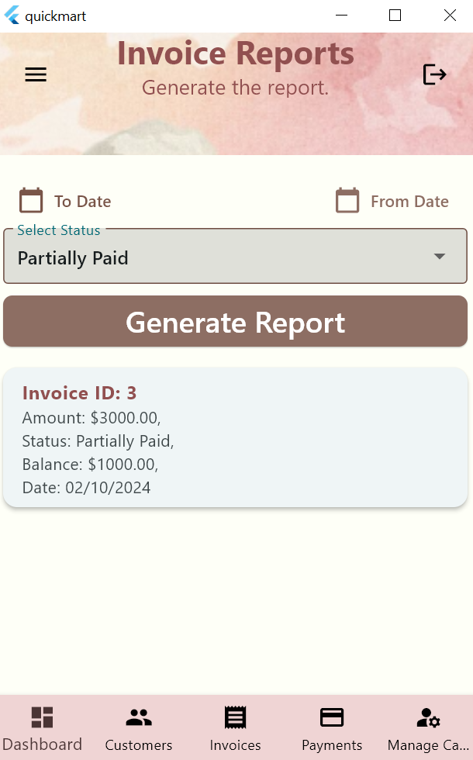

**I have worked on the Login, customers use cases and for that I created the following files**

**Under *models* folder**

**address.dart**

**contact_details.dart**

**customer.dart**

**user.dart**

**Under *providers* folder**

**customer_provider.dart**

**user_provider.dart**

**Under *repo* folder**

**customers_repository.dart**

**user_repository.dart**

**Under *screens* folder**

**customer_editor_screen.dart**

**customers_screen.dart**

**login_screen.dart**

**Under *widgets* folder**

**add_customer.dart (add customer button)**

**customer_card.dart**

**error_alert.dart**

**Figma design**

|  |  |  |
| --- | --- | --- |
| **Login screen** | **Customers screen** | **Customers on medium screen** |
| **Customers on large screen** | | **Add/Update customer**   |  |  | | --- | --- | |  |  | |
| **Add customer on large screen** | | **Update customer on large screen** |

**Diagram Repositories**

